(Approx. 952 words)

The AX6 Wireless Router
David Kretchmar, Hardware Technician, Sun City Summerlin Computer Club
https://www.sscc.club
dkretch (at) gmail.com

Could a new wireless router featuring the latest 802.11AX (Wi-Fi 6) protocol solve internet connection issues in your home?

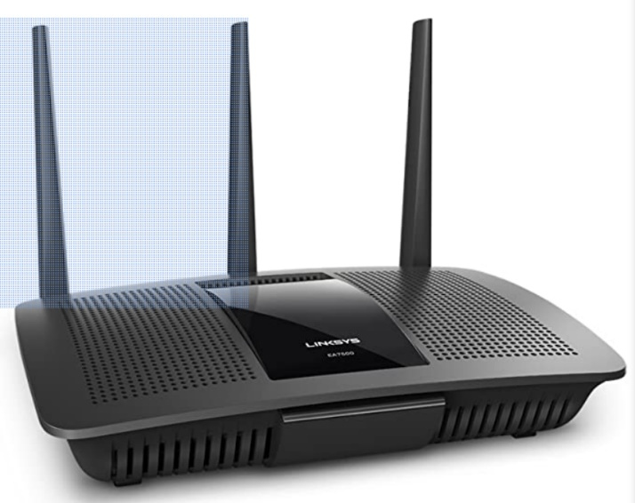
My old wireless router was a Linksys EA7500 Dual-Band Wi-Fi Router (AC), which supported up to 15 wireless devices. The dual-band feature, almost universal on routers today, supports 2.4GHz or 5GHz. So theoretically, you could take the maximum speeds of a band and then divide it by the number of devices on that band to determine the bandwidth available for each device.

The Linksys EA7500 router is an adequate router for its AC (Wi-Fi 5) class, with a total speed of 1.9Ghtz and other specs that far exceeded the broadband I was getting from Cox. It sells today on Amazon for $150.

That might sound like plenty of capacity, but wireless routers never reach their advertised maximum speeds. Real-world speeds are much slower and can vary throughout the day. A speed of around 5Mbps per device is sufficient for most purposes, but if the speed to a device is dropping too low single-digit Mbps, that could cause problems. The 5GHz band is generally faster but has a shorter range, making it work best for devices close to the router.

There are 11 channels on the 2.4GHz band; however, many overlap. The “clean” channels – 1, 6, and 11 – are the most popular Wi-Fi connections. A router will automatically pick a channel to use when set up. The problem is that the more popular channels are also subjected to more radio interference from everyday appliances such as microwave ovens and other technology, which means they can struggle to deal with many connected devices. In addition, most “smart” home devices use 2.4GHz channels, which can further clog things. You can often ease the load by switching to another channel (1, 6, or 11).

Too many devices

When I installed the Linksys router shortly after its release in 2016, the maximum 15 supported devices provided plenty of headroom, yet in 2021, that no-longer state-of-the-art home router seemed less than adequate. I was experiencing slow down and connection issues on my wireless devices. A quick audit of my wireless devices showed that the router was supporting a Ring doorbell, a printer, a tablet, two smartphones, two Alexas, three security cameras, three smart TVs, and up to four wireless computers. If you are counting, as many as 17 devices are supported by one router! Of course, all 17 devices would never be making demands on the router simultaneously, but the number of potential clients could produce enough traffic to overwhelm my router.

Speed Tests

I set out to determine the source of my troubles. First, I tested 2.4GHz wireless speeds in my home using free PCMatic software. My ISP is Cox Internet Preferred 150, nominally 150Mbps.

Internet computer connection speeds via Ethernet connection to the router. 180.4 Mbps | Internet computer connection speeds via a close wireless connection (< 10 feet from router). 57.2 Mbps
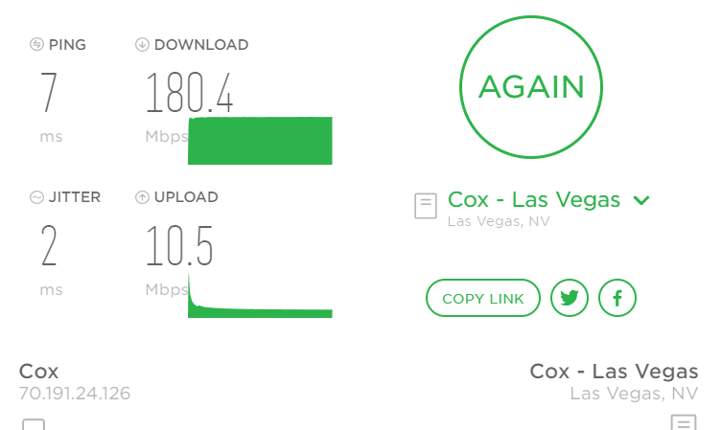 | 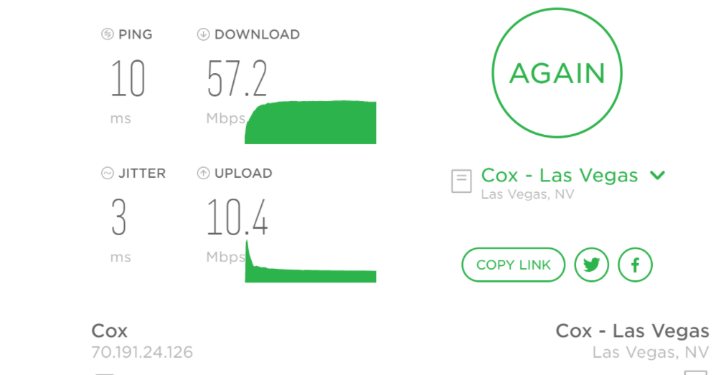
Internet computer connection speeds via the farthest wireless connection (40+ feet from the router). 15.8 Mbps
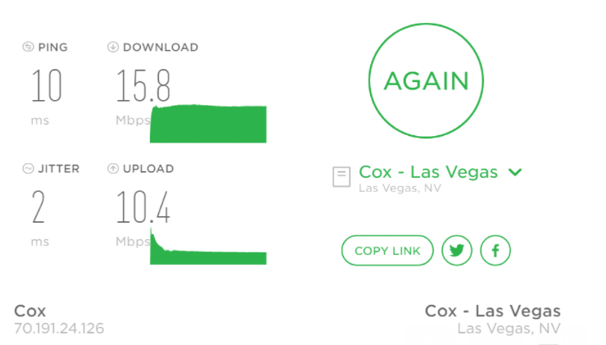

So, I was receiving a fast internet connection, 180Mbps, yet this seemed to be too rapidly dissipating in my home, especially at a distance from the router.

The two devices in my home connecting me to the internet are the modem and the router. If you have cable internet broadband from a provider that uses coaxial cables to deliver bandwidth, like Cox, you have a DOCSIS modem or modem/router combo. There are two DOCSIS standards, 3.0 and 3.1. The most significant difference between DOCSIS 3.0 and 3.1 is that 3.1 can support download speeds ten times faster than DOCSIS 3.0, up to 10Gbps.

A new modem?

My modem, a 6-year-old DOCSIS 3.0 unit, was my first suspect since I was aware that DOCSIS 3.1 was the newest standard for modems. But my internet plan comes with top speeds of less than 200Mbps. If you rent your modem or modem/router combo from Cox, and your plan provides less than 200Mbps, the modem included with your equipment is likely a DOCSIS 3.0 model, which is adequate for supporting most home internet connections. I learned I would probably see little or no performance improvement by using a DOCSIS 3.1 device over a DOCSIS 3.0. And considering the price difference, replacing the 3.0 with a 3.1 would probably be a waste of money.

A new router?

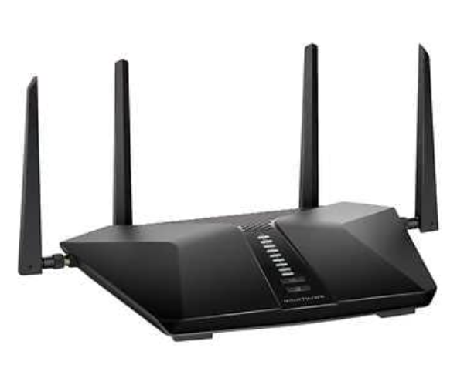
The logical solution seemed to be to try a new router. More specifically, a router with Wi-Fi 6 capabilities (which should help in the future as more mobile devices become compatible with the latest standard) and routers that can switch between bands automatically. This means that Wi-Fi 6 routers detect when specific devices use a lot of bandwidth and slow everything down, then move them to the 5GHz band or back to help manage speeds. It’s a great feature that self-manages the problem.

The new Netgear Nighthawk AX6 router

Costco had a great special on the highly-rated Nighthawk AX6 wireless router, so that seemed like a logical option. The new router was pretty easy to install, and the improvement was dramatic. Download speeds more than doubled at my most remote wireless device and almost tripled at my closest wireless device. But, as might be expected, the download speed of my Ethernet-connected computer was unchanged.

The only issue was that an older network adapter on one laptop required a driver update to recognize the AX6 signal. And it is a hassle to reset some networked devices, such as Ring.

If you have connection issues and your router is a few years old, consider upgrading to the newest protocol, an AX6 router.

